A000-Afr-Gabon- Ngounie Province -Tshogo-Door-Early 20th c

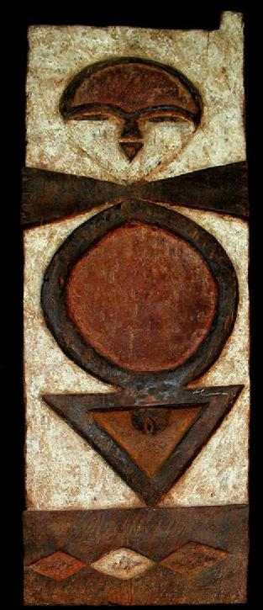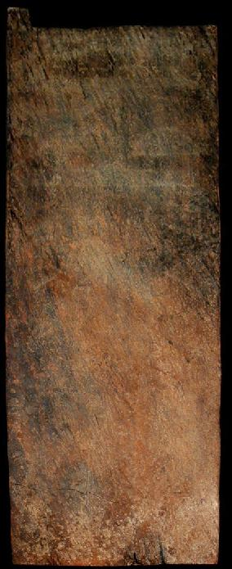

Figs. 1-2. Afr-Gabon- Ngounie Province -Tshogo-Door-Early 20th c

Case No.:

**Accession No.**

**Formal Label:** Afr-Gabon- Ngounie Province -Tshogo-Door-Early 20th c

**Display Description:**

The Tsogo people live north and east of Mauila in the Ngounie Province of Gabon and their population in 2000 was 37, 047. They speak a language called Tsogo and are part of the Northwest Bantu people cluster. Some alternate names for this people group include Getsogo, Ghetsogo, or Mitsogo. The Tsogo moved to their current location with the hope of escaping Bakele slave raiders but still suffered considerably at the hands of their foes. The French came and founded a military garrison in their region in 1899 which offered protection from other people groups; however, the French often demanded large amounts of products in exchange for such protection. During the late 1930's, gold was discovered in the Tsogo territory and many different peoples invaded in order to prosper from the newfound riches. Today, most of the Tsogo people make a living agriculturally (Olson 1996).

**LC Classification:**

**Date or Time Horizon:**

**Geographical Area:**

**Map:**

**GPS coordinates:**

**Cultural Affiliation:**

**Media:** wood, polychrome.

**Dimensions:** 40.15 inches x 11.811 inches,

**Weight:** 15.384 pounds

**Condition:**

**Provenance:**

**Discussion:**

**References:**

Olson, James Stuart. 1996. *The peoples of Africa : an ethnohistorical dictionary*. Westport, Connecticut: Greenwood Press, 1996.